Faceted data
I think this is a logical way to protect data, echoing authentication methods used in operating systems, allowing different views of data based on privileges, rather than an all-or-nothing approach such as masking all data to all parties, however it seems that this is a more dynamic method, enforcing security rules at each step, based on updated evaluations (Schmitz et al., 2016).
The advantage of using faceted value evaluation is that it is more flexible than traditional approaches; for example, some data can be later declassified and released to public users (Schmitz et al., 2016).
Faceted data evaluation processes more programs and allows more data to be publicly viewed than other systems (that will often reject valid programs based on their evaluations) results in the correct execution of more programs (Schmitz et al., 2016). This can be viewed as an advantage in terms of improving accuracy of evaluations, however such evaluations could result in a longer runtime to allow for the processing of more programs.
Ontology
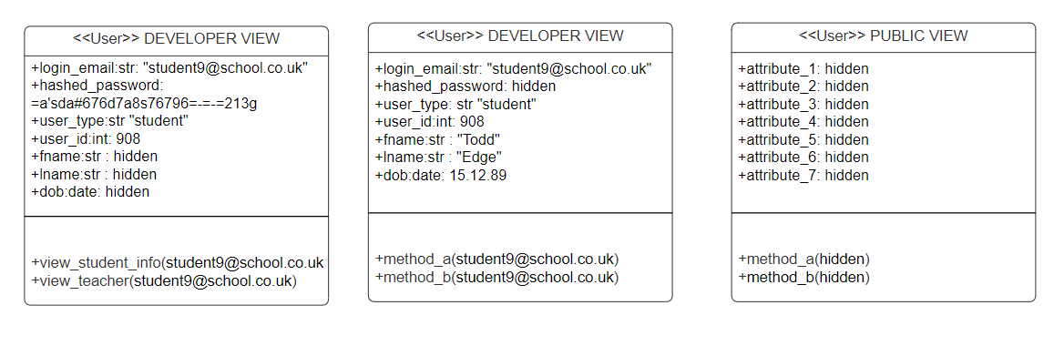
References
Schmitz, T., Rhodes, D., Austin, T.H., Knowles, K., and Flanagan, C. (2016) ‘Faceted Dynamic Information Flow via Control and Data Monads’, in Piessens, F. and Viganò, L. (eds.) Principles of Security and Trust. POST 2016. Lecture Notes in Computer Science, vol. 9635. Berlin, Heidelberg: Springer. DOI: 10.1007/978-3-662-49635-0_1.

